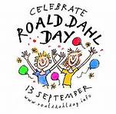
Nightingale will join others across the country on Tuesday 13th Septemeber 2016 to take part in The Dahlicious Dress Up Day by dressing up as their favourite Roald Dhal character. It will be in aid of Roald Dhal’s Marvellous Children’s Charity, helping children in the uk living with serious, rare and undiagnosed conditions.

We are asking for a £1 contribution to raise money for Roald Dahl’s Childrens’d charity.

You can find lots of costume ideas on www.roalddahl.com

