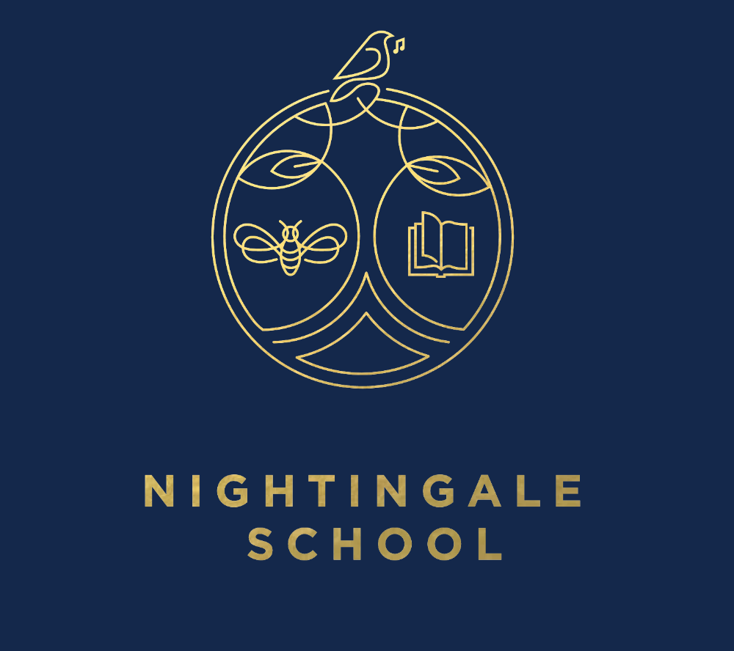

A New Logo for Nightingale
Dear Parents / Carers,
As you know, Nightingale is going to be moving to a new school building in December 2018. To go with this move, I would like to introduce a new logo for our school. We were very lucky to receive an offer from a top London design agency, Steve Edge Design Ltd, who have worked with a group of our children to design the proposed logo you can see here. It contains a tree, representing strength, a bee to represent teamwork, an open book to represent stories and knowledge, and of course, a Nightingale singing to represent the individual brilliance that our children have.
I would love to know what you think of the new design, so if you have any comments please feel free to see me on the playground or to fill in the form below and return it to your child’s class teacher.
With best wishes,

Mrs Hopper
__________________________________________________________________________________
Name of child __________________________________ Year group ____________________
I would like to make the following comments on the proposed new logo for Nightingale Primary:
__________________________________________________________________________________
__________________________________________________________________________________
__________________________________________________________________________________
__________________________________________________________________________________

