Say Hello to our Nightingale reporters. They will have full editorial control of the newsletter during science week which will run from Monday 8^{th-} Friday 11th of February this year.
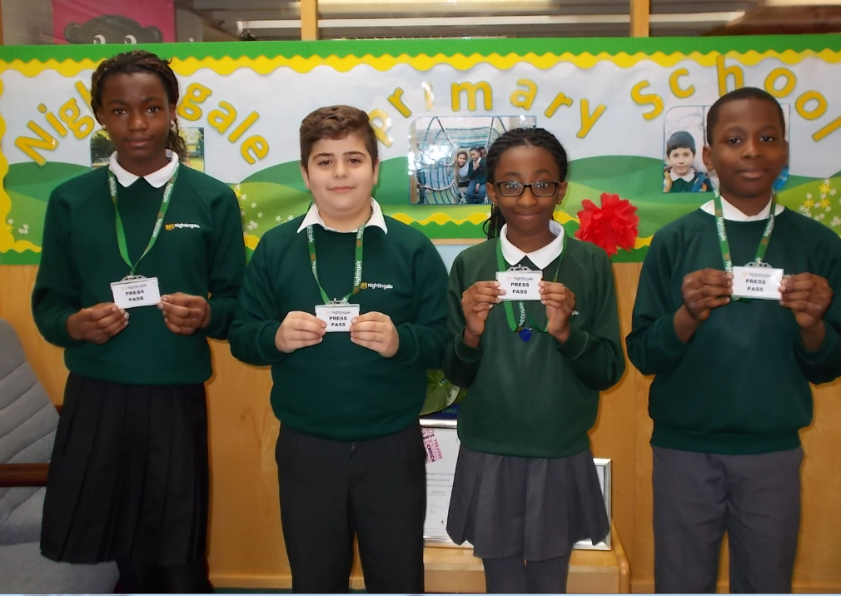
Science Topics for iDiscover 2016
Nursery and Reception-Forensics
Year 1- Robots and Machines
Year 2-My Biology
Year 3- Food
Year 4-Jobs in the entertainment business
Year 5-Design and make a robot
Year 6-Exploring jobs of the future
Make sure you keep an eye on our website to see what’s happening!

