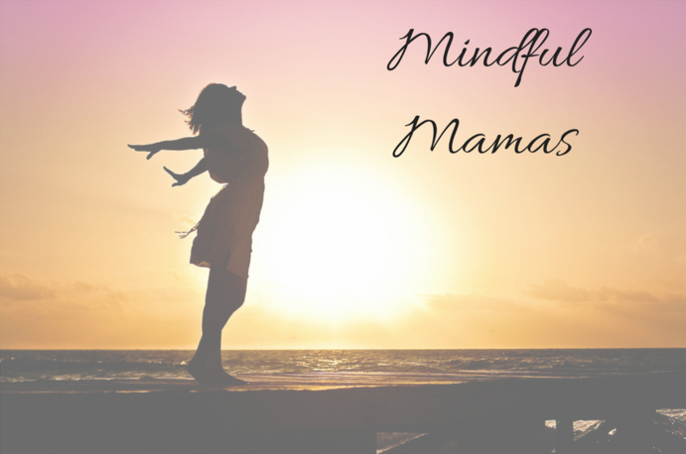
ESOL for Health

mindful mama

  - Are you a mum, aunty or grandma at Nightingale school?
  - Do you want to practise your English with a friendly group of women?
  - Are you interested in health, wellbeing, diet and exercise for yourself, your children and your school community?
then come and join Mindful Mama!
at Nightingale Primary School
Every Wednesday from 9.15-11.15am
Free Crèche Free T-shirt! Outing and Celebration for Champions

As a part of our special ESOL course, you will:
- Learn all about Mindfulness- for relaxation, healthy eating and exercise.
- Feel confident to talk to your GP and Pharmacist.
- Become a Mindful Mama Champion, helping your child, other parents,
and your school to feel happier, healthier and live stress free.

For more information contact! Birsel Cinar (07885367248) Chinar Mohammad (07525598495) or schools office (020 8985 4259).

