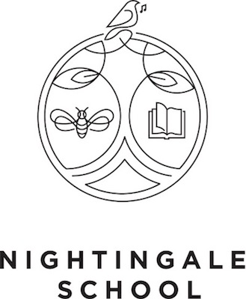

Purpose
We empower our community today to create brilliant citizens for the world tomorrow.

Guiding Principles:
- Inspirational Teaching – Creating exceptional learning experiences for every child, every day

- No One Left Behind- Being flexible in our approach and never giving up

- Create the Safe Space - Listening with patience and understanding, building supportive relationships

- Innovating Together– Never standing still, always looking to improve, willingly accepting help and guidance from our strategic partners

- Lead by Example – Community, Inclusion and Respect at the heart of all we do

Strategic Priorities 2021-22
GET ONLINE – Support the learning of all pupils by engaging children and their families using online resources to communicate, teach and collaborate.

POLISH OUR PEDAGOGY – MATHS FOCUS
Ensure, through effective CPD and work with strategic partners, that Maths teaching across the school is highly effective and follows closely the Mathematics Mastery scheme of work and methodology.

TURBO-CHARGED PROGRESS Ensure through the effective use of assessment and responsive teaching in all Key Stages that gaps in children’s learning are identified and addressed through quality first teaching and the use of tutoring.

PROGRESSION IN THE HUMANITIES CURRICULUM
Put in place effective planning for humanities subjects so that children’s learning evidences progression in skills and knowledge.

3 Year Goal
To be the most popular school in Hackney* thanks to our happy children, outstanding curriculum and high academic achievement.

*measured on First Choice Applicants to Reception

Critical Number (Spring Term)
% of children reaching AREs in Reading, Writing and Maths in Years 1-6 by Summer 2 :
End of Year Target – Combined 62%

Current – end of Autumn Term | Combined - 44%  Reading – 64%  Writing – 58%  Maths - 51%

Spring Term Priorities
EYFS
Work with Wentworth Nursery on Action Research project to improve talk and vocabulary acquisition.

Lower Phase
Development of History Units to set a clear foundation of skills (Significance and Chronology Units)

Middle Phase Year 3 and 4
Raising the challenge in humanities lessons (Use of Mary Myatt Training and Resources)

Upper Phase
Raising the challenge in humanities lesson (Use of Mary Myatt Training and Resources)

Whole School

Have in place progression documents and effective planning for all teaching in History and Geography. Check alignment to these plans through effective monitoring by curriculum lead.

